[](http://web.archive.org/web/)

|  |  |  |  |  |  |  |  |  |  |  |  |
| --- | --- | --- | --- | --- | --- | --- | --- | --- | --- | --- | --- |
| Top of Form    Bottom of Form | | |  |  |  | | --- | --- | --- | | [**FEB**](http://web.archive.org/web/20060213015330/http:/www.homeracingworld.com:80/artinpowerupgrade.htm) | **MAR** | [**JUL**](http://web.archive.org/web/20060708112758/http:/www.homeracingworld.com:80/artinpowerupgrade.htm) | | **[Previous capture](http://web.archive.org/web/20060213015330/http:/www.homeracingworld.com:80/artinpowerupgrade.htm)** | **28** | **[Next capture](http://web.archive.org/web/20060708112758/http:/www.homeracingworld.com:80/artinpowerupgrade.htm)** | | [**2004**](http://web.archive.org/web/20041206040137/http:/www.homeracingworld.com:80/artinpowerupgrade.htm) | **2006** | [**2007**](http://web.archive.org/web/20070416041508/http:/www.homeracingworld.com:80/artinpowerupgrade.htm) | |
| [**18 captures**](http://web.archive.org/web/*/http:/www.homeracingworld.com/artinpowerupgrade.htm)  4 Dec 2003 - 28 Feb 2015 |  |

[About this capture](http://web.archive.org/web/20060328030955/http:/www.homeracingworld.com/artinpowerupgrade.htm#expand)

[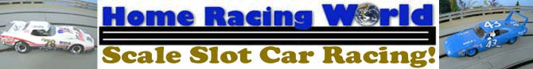](http://web.archive.org/web/20060328030955/http:/www.homeracingworld.com/index.htm)

Tuesday October 28, 2003

***Upgrading Artin Part 3***

***After-Market Power***

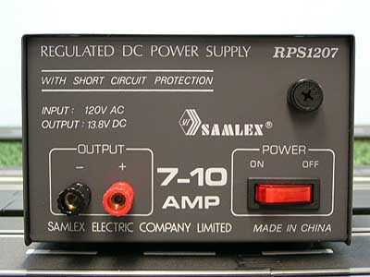***Since our last upgrade using the Ninco Transformers, we have decided to use higher quality after-market power for our Artin track. Using the new Samlex RPS 1207 or 1203 is a much better choice not only in quality but in price. For those looking for more information on these power supplies and why we chose them try***[***going here***](http://web.archive.org/web/20060328030955/http:/www.homeracingworld.com/samlexpower.htm)***. After your finished reading that article, now its time to hook it up to our Artin Power Base.***

Let just begin by saying this is so easy...that anyone can do it. Using your existing Artin Power Base and Artin Transformer plug, you will be upgraded in no time.

First take a look at your current transformer with the 2 plug ends coming out of it. For the 4 lane set up you will need both leads. Start by using a wire cutter and cut the wires from the transformer about 6 inches from the transformer end. This leaves a little room in case you ever want to use this old transformer for other purposes or to give it to a friend to use.

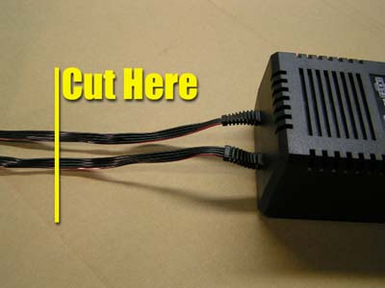

Look closely at the 4 wires on each plug end. You will see a small red stripe on the top wire. The wires are staggered sequence meaning the top wire (#1) is positive, the next wire(#2) negative, then positive (#3) and then finally negative (#4). With us so far?

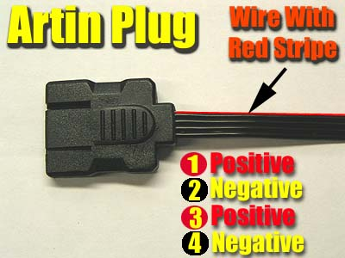 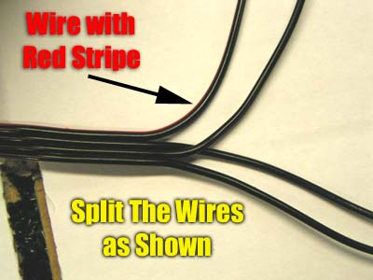

Now using a side cutter or Exacto blade, cut the wire insulation so you can pull them apart from each other as shown in the photo. Once this is done, trim away the insulation from the ends of the wire so we can hook them to a connector. Now here you can either do this one of two ways. You can hook BOTH Artin plugs together and just use 2 connectors, or you can do each plug separately. Either way will work so don't worry which way is best.

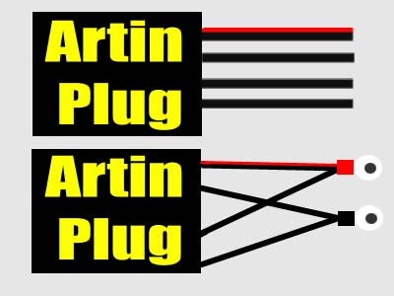

Starting with the top wire (one with red stripe) take it and next positive wire (3rd wire) and twist them together. Now just take the 2 remaining negative wires and do the same. You are almost finished and the "hard" part is over.

Time to choose a connector. You can either choose a banana style plug such as those found in Radio Shack, but using a standard eye connector will work just as easily, are less expensive and can be found just about anywhere.

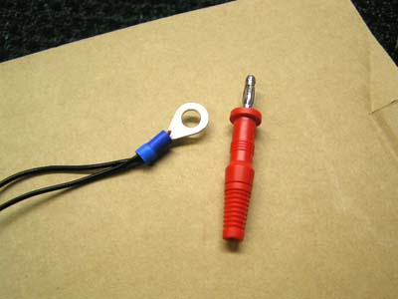

***Connect your wires to the connector of your choice and then attach it to your power supply, positive to red...negative to black. You are finished...not as hard as you thought right?***

***- Harry***

If you any questions, or need further help in this modification please feel free to [contact me](http://web.archive.org/web/20060328030955/mailto:harry@homeracingworld.com?subject=Power%20Supply%20Hook-Up). Our goal is to help you get the most out of your hobby so by all means let us know.

**Notice**

If you want, just send me your Artin wires after you cut them from the transformer (saves shipping costs) and I will wire them for you at no charge. Or if you order a new set from us and plan to use after-market power, upon request I will perform the above modification to your wiring before we ship.

[](http://web.archive.org/web/20060328030955/http:/www.slotcarplace.com/) [](http://web.archive.org/web/20060328030955/http:/www.slotcarworld.com/) [http://web.archive.org/web/20060328030955im_/http:/www.homeracingworld.com/khbannernew.jpg](http://web.archive.org/web/20060328030955/http:/www.kandhracin.com/)

[](http://web.archive.org/web/20060328030955/http:/www.homeracingworld.com/index.htm)